**Create a Spring Web Project using Maven**   
  
Follow steps below to create a project: 

1. Go to <https://start.spring.io/>
2. Change Group as “com.cognizant”
3. Change Artifact Id as “spring-learn”
4. Select Spring Boot DevTools and Spring Web
5. Create and download the project as zip
6. Extract the zip in root folder to Eclipse Workspace
7. Build the project using ‘mvn clean package -Dhttp.proxyHost=proxy.cognizant.com -Dhttp.proxyPort=6050 -Dhttps.proxyHost=proxy.cognizant.com -Dhttps.proxyPort=6050 -Dhttp.proxyUser=123456’ command in command line
8. Import the project in Eclipse "File > Import > Maven > Existing Maven Projects > Click Browse and select extracted folder > Finish"
9. Include logs to verify if main() method of SpringLearnApplication.
10. Run the SpringLearnApplication class.

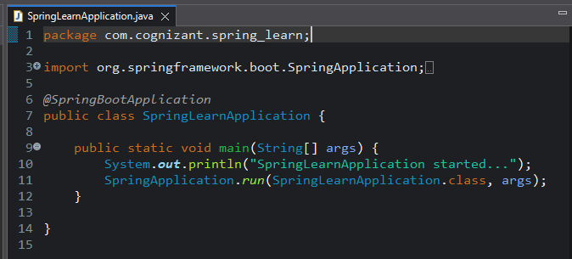

OUTPUT:

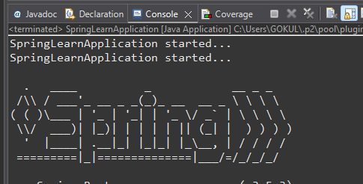

**SME to walk through the following aspects related to the project created:**

1. src/main/java - Folder with application code

**src/main/java**

* Contains all **Java source code**.
* Includes the com.cognizant.springlearn package.
* Entry point: SpringLearnApplication.java.

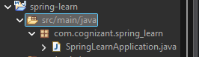

1. src/main/resources - Folder for application configuration

**src/main/resources**

* Stores **configuration files**:
  + application.properties – Default Spring Boot config file.
  + Add additional files like messages.properties, logback.xml, etc.

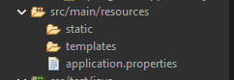

1. src/test/java - Folder with code for testing the application

**src/test/java**

* Placeholder for **JUnit test cases**.
* Used for unit and integration testing.



1. SpringLearnApplication.java - Walkthrough the main() method.



1. Purpose of @SpringBootApplication annotation

This annotation is a combination of:

* @Configuration: Marks class as a source of bean definitions.
* @EnableAutoConfiguration: Enables Spring Boot’s auto-configuration.
* @ComponentScan: Scans current and sub-packages for components (controllers, services, etc).

Acts as the **starting point** for Spring Boot applications.

1. pom.xml
   1. Walkthrough all the configuration defined in XML file
   2. Open 'Dependency Hierarchy' and show the dependency tree.

Project Coordinates:

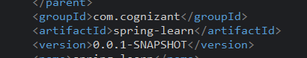

Dependencies:

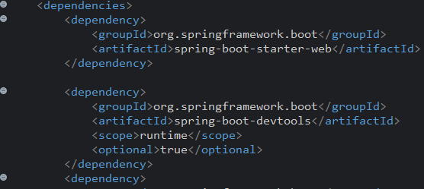

Build Plugins:

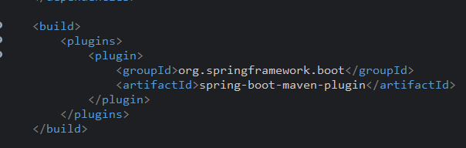

Once you’ve run SpringLearnApplication, check the **console output** :

